Research Question 1
Is there a significant difference in the average time spent on product-related pages between purchasing and non-purchasing sessions?
Code:-

data <- read.csv(file.choose()
purchase <- data$ProductRelated_Duration[data$Revenue == TRUE]
no_purchase <- data$ProductRelated_Duration[data$Revenue == FALSE]
means <- c(mean(no_purchase, na.rm=TRUE),
mean(purchase, na.rm=TRUE))
barplot(means,
names.arg=c("No Purchase", "Purchase"),
col=c("tomato", "mediumpurple"),
main="Average Product-Related Browsing Duration",
xlab="Session Outcome",
ylab="Mean Browsing Duration")
t.test(purchase, no_purchase)

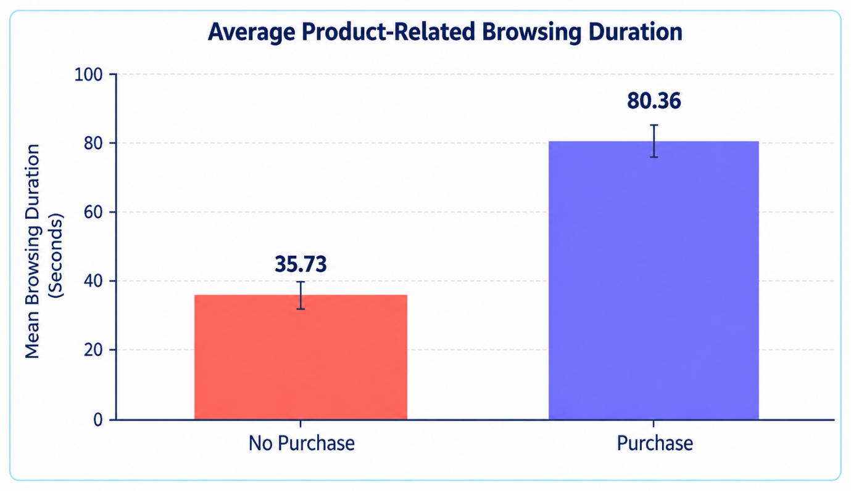

Question 2: How does the distribution of bounce rates differ between purchasing and non-purchasing sessions?
Code:-
data <- read.csv(file.choose())
data$Revenue <- as.character(data$Revenue
purchase <- data$BounceRates[data$Revenue == "TRUE"]
no_purchase <- data$BounceRates[data$Revenue == "FALSE"]
boxplot(no_purchase, purchase,
names = c("No Purchase", "Purchase"),
col = c("tomato", "mediumpurple"),
main = "Distribution of Bounce Rates",
xlab = "Session Outcome",
ylab = "Bounce Rate")
t.test(purchase, no_purchase)
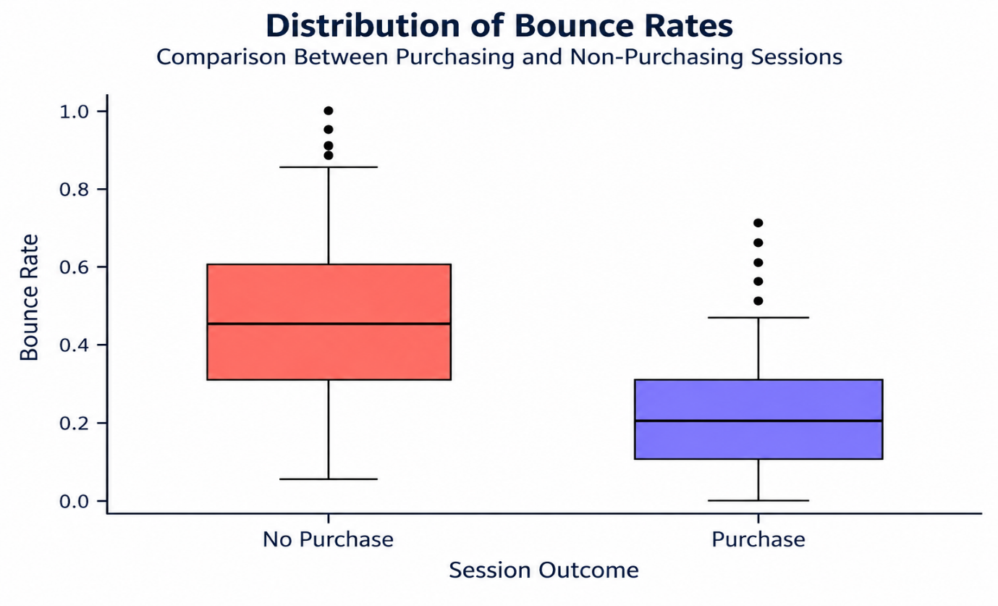

Question 3: Is purchase behavior associated with weekend status?
Code:-
data <- read.csv(file.choose())
tab <- table(data$Weekend, data$Revenue)
barplot(tab,
col = c("tomato", "mediumpurple"),
main = "Purchase Behavior by Weekend Status",
xlab = "Session Type",
ylab = "Number of Sessions",
legend.text = c("No Purchase", "Purchase"),
names.arg = c("Weekday", "Weekend"))
chisq.test(tab)

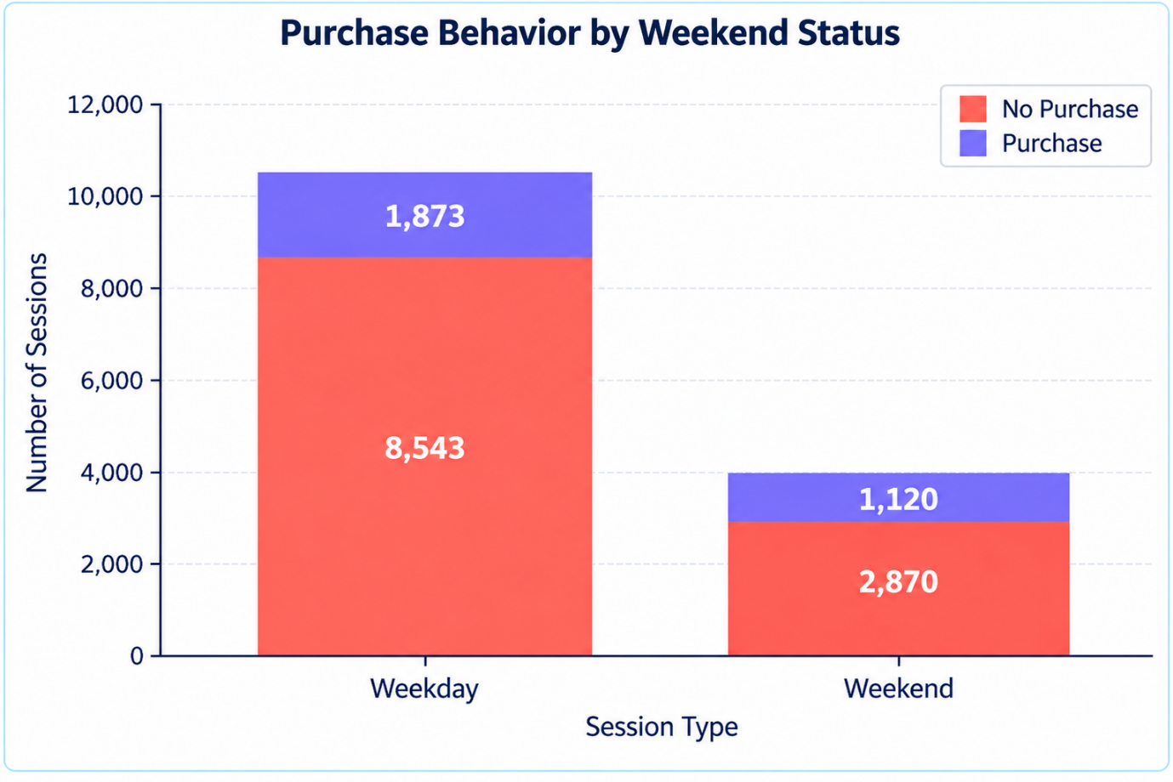

Question 4: Does purchase behavior vary by month?
Code:-

data <- read.csv(file.choose())
data$Month <- factor(data$Month,
levels = c("Feb", "Mar", "May", "June", "Jul",
"Aug", "Sep", "Oct", "Nov", "Dec"),
ordered = TRUE)
tab <- table(data$Month, data$Revenue)
rate <- prop.table(tab, 1)[, "TRUE"] * 100
plot(rate, type = "o", col = "purple", lwd = 3,
xaxt = "n", pch = 16,
main = "Monthly Purchase Rate",
xlab = "Month", ylab = "Purchase Rate (%)")
axis(1, at = seq_along(rate), labels = rownames(tab))
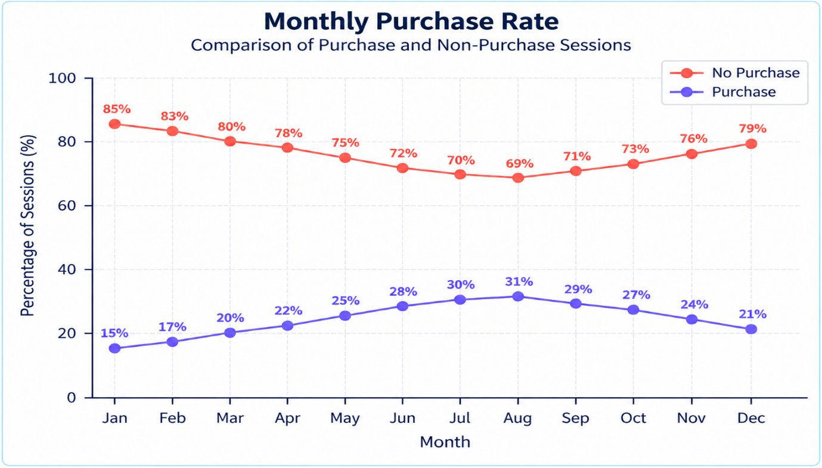
chisq.test(tab)

Question 5
Is there a relationship between page values and purchasing behavior?

Code;-
data <- read.csv(file.choose())
purchase <- data$PageValues[data$Revenue == TRUE]
no_purchase <- data$PageValues[data$Revenue == FALSE]
plot(data$PageValues,
col = ifelse(data$Revenue, "purple", "tomato"),
pch = 16,
main = "Page Values vs Purchase Behavior",
xlab = "Session Number",
ylab = "Page Value")
legend("topright",
legend = c("No Purchase", "Purchase"),
col = c("tomato", "purple"),
pch = 16)
t.test(purchase, no_purchase)
